|  |  |  |  |
| --- | --- | --- | --- |
| cit-bw | Corporate Finance Department Purchasing Division |  | |
|  |  | 421-2024  (Bid/Proposal No.) ADDENDUM 04 (Addendum No.) | |
|  |  | **SUPPLY AND DELIVERY OF TRENCH LAUNCH STEERABLE HORIZONTAL THRUST BORING MACHINE ASSEMBLY *(Contract Title)*** | |
|  | | | ISSUED: 2024-09-20*(date)* |
|  | | | BY: Dennis Kwast *(name)* |
| URGENT **PLEASE FORWARD THIS DOCUMENT TO WHOEVER IS IN POSSESSION OF THE Bid/Proposal** | | | TELEPHONE NO. 431 336-1767 |
|  | | | THIS ADDENDUM SHALL BE INCORPORATED INTO THE BID/PROPOSAL AND SHALL FORM A PART OF THE CONTRACT DOCUMENTS  Template Version: Add 2024-02-01 |
|  | Please note the following and attached changes, corrections, additions, deletions, information and/or instructions in connection with the Bid/Proposal, and be governed accordingly. Failure to acknowledge receipt of this Addendum in Paragraph 10 of Form A: Bid/Proposal may render your Bid/Proposal non-responsive. | | | | |  |
|  |  | | | | |  |

#### FORM B: PRICES

Eg. Replace: 144-2006 Form B: Prices with 144-2006 **Addendum 1** Form B: Prices

Form B(R3): To distribute Form B as Excel.

SPEC NOTE: When replacing a form, make sure to **add the addendum number in the header and add the revision number (R#)** to the form that’s being replaced. See example below:

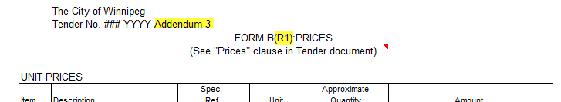

SPEC NOTE: Insert revised clause in its entirety.